Fire Risk Assessment - Holy Trinity Tewkesbury

Version Control
Version | Date | Comment
3.0 | 04/10/2024 | Initial Full Version. Some points outstanding
3.1 | 26/10/24 | Minor clarifications
3.2 | 08/11/2024 | As approved by PCC

Part 1 – Information About Our church

Our Church Details
Holy Trinity Church Tewkesbury The Parochial Church Council of: Holy Trinity Tewkesbury
Oldbury Road Tewkesbury GL20 5NA In the diocese of: Gloucester

Responsible person: Church Wardens Date: 26th October 2024
Review date: October 2025

(The generic guidance provided with the template is shown in italics, where this clarifies the information provided in the assessment)
(This assessment should be reviewed at least annually unless there is a change that materially affects the fire risk such as a change in the method of heating or use of the building, when it should be reviewed immediately.)

Parochial Church Council Declaration
As a church, we understand that we are required to undertake a Fire Risk Assessment in accordance with the Regulatory Reform (Fire Safety) Order 2005 (in Scotland, fire safety duties are contained in part 3 of The Fire Scotland Act 2005, as amended and The Fire Safety Scotland Regulations 2006) even if we have no employees.
We note that we are required to take such general fire precautions as will ensure, so far as is reasonably practicable, the safety of employees, if we have any, and to take such general fire precautions as may reasonably be required in the circumstances to ensure that the premises are safe for all other visitors to the church including volunteers, members of the congregation, and contractors. Our Fire Risk Assessment and arrangements are therefore directed to the safety of people rather than the protection of the building itself.
We understand that we must appoint a responsible person and other competent persons to give effect to such arrangements as are appropriate, having regard to the size of our undertaking and the nature of our activities, for the effective planning, organization, control, monitoring and review of the preventive and protective measures. In the case of a church, we understand that the responsible person is the person who has control of the premises and we deem this to be the ‘Body Corporate’ namely the Parochial Church Council. We have also appointed the Parochial Church Council as the Competent Persons under the legislation.
Although the legislation only requires the responsible person to record the arrangements if five or more persons are employed, we have decided to do so in order to demonstrate our commitment to ensuring the safety of everyone who uses our church and to ensure that everyone is aware of our fire safety arrangements.
We understand that the legislation is not prescriptive and that we are only required to undertake preventive measures ‘where necessary’.
In carrying out our Fire Risk Assessment, we have followed the Government guidance published by the Department for Communities and Local Government (for Scotland – Scottish Government’s Police and Community Safety Directorate, HM Fire Service Inspectorate for Scotland, the Scottish Building Standards Agency and the Health and Safety Executive) and have noted from this document that the action we take should be common sense and in the main, not expensive. We have also noted Appendix C of the guidance for Fire safety risk assessment: small and medium places of assembly which refers to listed and historic buildings and note that we will need to endeavour to strike a balance between ensuring sufficient fire safety measures are in place for the safety of people, yet avoid extensive alterations and helping to maintain the character of the building.

Signed on behalf of the PCC:
PCC Chair: Date:

You can see the full documentation referred to above at the links below:
Regulatory Reform (Fire Safety) Order 2005: www.legislation.gov.uk/uksi/2005/1541/contents/made
Government Guidance including a fire risk assessment form is available from:
www.communities.gov.uk/fire/firesafety/firesafetylaw/aboutguides/
A document that may also be of assistance is the Fire Safety Risk Assessment Small and Medium Places of Assembly: www.gov.uk/ government/collections/fire-safety-legislation-guidance-for-those-with-legal-duties

General Information About Our Church
THE BUILDING:
(You will need to measure the building to calculate things like the number of fire extinguishers required and travel distances. See also ‘Plan’ below.)

Building description:

Church – Nave, Vestry, Foyer, Creche. Door from nave to vestry. Glass screen and door to foyer. Glass screen and doors to creche. Glass doors to front door to porch. 2 enclosed stairs to balcony with doors to foyer and fire doors to outside. Vestry has fire door with steps down to garden. Foyer has ramp and doors to hall complex. Number of floors: 4 Floor area: = 340m²

Nave 23.3 x 10.6m = 246 sqm Foyer 7.2 x 3.3m = 24 sqm

Creche 5.12 x 3.19m = 16sqm Balcony 5.12 x 10.5m = 54sqm

Total 340sqm

Halls - double entrance glass doors to lobby and corridor, toilets, kitchen, 4 meeting rooms, 3 storage rooms and kitchen and boiler room off corridor. Fire exit through double doors at far end of main hall. Number of floors: 1 Floor area: 639m²

Room 1: 3.77 x 5.99m=22.6sqm Room 2: 7.43 x 5.96m = 44.3sqm

Room 4: 15.01 x 9.02m = 135.4sqm Room 5: 4.31 x 3.00m = 12.9sqm

Total 639.72sqm

OMH - one large and one small meeting room, plus two toilets and kitchenette and one storage room. Fire exit from large room is through main front door. Fire exit from small meeting room is through window. Number of floors: 1 Floor area: 72m²

The large room is 29 feet 4 inches by 19 feet 6 inches (8.9 x 5.9m= 52.5sqm)

The small room is 15 feet 5 inches by 15 feet 2 inches (4.7 x 4.1m =19.2sqm)

Total 71.7sqm

Office – three storey terrace property, 2 rooms plus kitchen on ground floor, one room plus bathroom on first floor, one room plus attic on second floor. Fire exits through ground floor through front and rear of building. Number of floors: 3

Office - 4 x 3.35m = 13.4 sqm

Office - 3.75 x 3.25m = 12.1 sqm

Kitchen 3 x 3.25m = 9.75 sqm

1st Floor Meeting - 4 x 3.35m = 13.4 sqm

2nd Floor Meeting - 4 x 3.35m = 13.4 sqm

Total: 62.1 sqm excluding bathroom

Basic construction details:

Church -The church is brick and stone, high vaulted ceiling, tiled roof. Wooden floor with carpet covering

Halls – the halls are brick and breeze block, with felt roofing and false ceilings and solid floor covered with carpet tiles or limited carpeting. The hall way to each room has vinyl flooring. Flat roof above small meeting room (room 5)

OMH – The OMH is brick with slate roof refurbished in 2018 with vinyl flooring and carpet

Office – the Office is brick built with tiled roofing and a flat roof above the kitchen.

(For example, The church is built of stone/brick with a slate/tile roof on a timber frame. The floor is of solid construction covered with tiles.)

Use of the buildings:
Church – regular church services, two weekly plus occasional funeral services, baptisms, weddings, etc
Halls – childrens groups, community lunch, life groups, mother and toddler groups, ad hoc community room bookings, church meetings
OMH – twice weekly youth events, weekly community activities, ad hoc community room bookings, church meetings
Office – administrative centre for three members of staff plus the vicar and the curate.

PEOPLE AT RISK:

Occupants:
Approximate average number attending a normal service: Church - 150 – 200, halls 60 – 100 , OMH 25, office: 5

Approximate maximum number attending special services and events such as weddings and at Christmas: 400

Approximate number of employees and/or volunteers in the church at any one time: 30 (Sunday morning) 12 (Monday afternoon community meal)

OCCUPANTS AT SPECIAL RISK FROM FIRE:

Give details of any persons with disabilities who attend the church who would need help in evacuating the building:
Duty wardens and welcome team aware of those with limited mobility Generally max 2- 3 wheelchair users and perhaps 5 users of walkers. These visitors are encouraged to sit near the most accessible exit.

Give details of any children who attend the church and whether they occupy a different part of the building during services such as a Sunday School in the vestry:
- babies and toddlers in the creche – separate room at West end of Nave with own Fire Exit
- TJC/ Trinity Tribe – initially with parents in Nave, then in groups in hall rooms 1,2, 4,5 -
- Youth Grid/Energize - use of OMH

Give details of the number of persons who occupy remote parts of the building and when:
Employees and Church wardens accessing loft and attic for storage or maintenance purposes.
BACKGROUND INFORMATION:

Previous fire losses:
Detail any fires or related incidents that anyone can remember even if it did not result in an insurance claim:
None

Other relevant information:
(Any other information which could have a bearing on the risk of fire such as the nature of any nearby or adjoining premises or evidence of arson
None

Potential Fire Hazards At Our Church – applicable to church, halls, OMH and office

Where the answer is NO then some action may be required in order to ensure that your fire safety arrangements are satisfactory. This needs to be noted in the Action Plan at the end of the assessment. If the situation does not apply, enter N/A.
Electrical

Is the fixed electrical system inspected and tested by a competent person at least every five years? Yes No
If YES, state the name of the competent person and the date of the last inspection
MJF Electrical Jan 2022

Are all portable electrical appliances including those belonging to outside bodies annually Yes No
tested? (PAT testing)
If YES, state the name of the tester and the date of the last test
Last test Jan 2024, next test 2026 – every two years. By MJF Electrical

Are any electrical items that fail the testing removed immediately from the church? Yes No
Is the use of trailing leads and multi-point adaptors restricted as far as possible and Yes No
subject to control?

Heating

If portable electric heaters including electric fan heaters, and radiant ‘bar’ type fires Yes No N/A
are used, are they included in the PAT testing programme and are they kept away from combustible materials?
If portable LPG (liquid petroleum gas) heaters are used, are they fixed away Yes No N/A
from combustible materials and are the arrangements for the storage and replacement of spare cylinders satisfactory?
If heating appliances burning coal or other solid fuel, e.g. wood pellets, are used, Yes No N/A
are arrangements in place to ensure fire cannot spread accidentally?
Are gas boilers subject to an annual maintenance contract with an approved Gas Yes No N/A
Safe registered contractor?
If YES, state the name of the contractor and the date of the last inspection
ME Hooper - October 2024

Are oil-fired boilers subject to an annual maintenance contract with an approved Yes No N/A

OFTEC contractor?
If YES, state the name of the contractor and the date of the last inspection

Are oil tanks suitably bunded or double skinned and fitted with a safety cut-off valve? Yes No N/A
Do you ensure that all heating appliances are kept clear of combustible materials? Yes No

Arson
Have you considered the risk of arson and malicious attacks? Yes No
Is the storage of combustible materials and flammables such as petrol for mowers kept Yes No
to a minimum and in a secure place where the risk to people is minimised?
Have you removed or kept secure anything which could be used by an arsonist such as Yes No
matches and candles?

Cooking
If you have a kitchen or servery in the church, are measures in place to prevent fire as a Yes No N/A
result of cooking?
If Yes, what are these?
- No Deep fat frying
- Extraction filters cleaned regularly
- Fire blanket
If kitchen equipment includes filters or ductwork, are they cleaned regularly? Yes No N/A
If YES, state how often
twice yearly October and January

Are suitable fire extinguishers and a fire blanket located in the cooking area? Yes No N/A

Lightning

If the church has a lightning conductor, is it inspected by a competent, specialist Lightning Yes No N/A
Engineer at recommended intervals?
If YES, state the name of the contractor and the date of the last inspection
Lightning Consultants UK Lt October 2023

Combustible Materials

Has combustible material been removed from the church as far as possible? Yes No
(Examples of combustible material which can accumulate are hay and straw used in Christmas cribs, articles collected for jumble sales but never sold, waste paper collected for recycling and old Christmas trees.)

Are all exits and escape routes kept clear of combustible materials? Yes No

Contractors and Building Works
Are outside contractors subject to control when working in the church and are they Yes No
required to use a ‘hot work’ permit system when necessary? * to be reviewed as necessary
If volunteers undertake maintenance work in the church, are suitable precautions taken Yes No N/A
such as the use of a ‘hot work’ permit system and the provision of suitable fire extinguishers close to the location of the work?
Are both contractors and volunteers aware of safety arrangements including provision of Yes No
fire extinguishers and escape routes during building works?

Hot work on building contracts or volunteer activities in the future is likely to be very limited. Appropriate precautions will be agreed with contractors where necessary.
E. Our Fire Protection Arrangements
Means of Escape  Are there a suitable number of exits from the building? |  | No
This is addressed under the arrangements for Fire Safety Management.

Church Yes

Halls Yes

OMH Yes

Office Yes
(As a guide, it should be possible to evacuate the building in less than 2.5 minutes although this time may be extended for low-risk buildings such as churches. Guidance also indicates that one exit is sufficient for up to 60 persons but if the building can accommodate more than 60 persons there should be more than one exit. It will not normally be possible to increase the number or width of doors in a church but remember that doors not normally in use such as external doors to vestries may be used.)
A test evacuation of a Sunday congregation in 2024 cleared the church in 2.6 minutes

Do the exit doors open in the direction of escape?

Church Yes

Halls Yes

OMH No

Office No
This is addressed under the arrangements for Fire Safety Management.
OMH and Office have limited occupancy and the doors open easily

Can exit doors be opened easily?
Doors are unbolted, have panic bars, or fire wardens are assigned when the church is full.
OMH door opens with a single lever handle
Office doors have simple domestic style locks operated from inside without a key
This is addressed under the arrangements for Fire Safety Management.
Is the travel distance acceptable where there is only a single escape route?

Church Yes

Halls Yes

OMH Yes

Office Yes

Is the travel distance acceptable where there are alternative means of escape?

Church Yes

Halls Yes

OMH Yes

Office Yes (not on second floor )
(The travel distance is the furthest a person would have to travel from a point within the church in order to reach an exit door. For areas with seating in rows, such as is found in the majority of churches, guidance suggests the following travel distances:
Where there is only a single escape route, the maximum distance is 15 metres for a normal fire risk area and 18 metres for a lower fire risk area;
Where there is more than one escape route, the maximum distance is 32 metres for a normal fire risk area and 45 metres for a lower fire risk area.
In the case of vestries that have their own external door, travel distances will normally fall within these guidelines.
The main body of the church may be regarded as a lower fire risk area and in most cases the travel distances should be within the guidelines.
However, you do need to measure travel distances in order to answer this question. Where they exceed the guidelines, it will need to be addressed under the arrangements for Fire Safety Management.)

Are escape routes suitably protected from fire and kept clear of obstructions at all times? Yes No
(In practice, unlike many other buildings, traditional churches have very few corridors so the ‘escape route’ is effectively the whole of the building. The porch is the most likely area to pose a risk of obstruction during an evacuation and must be kept clear of obstructions and combustibles such as free-standing noticeboards and displays.)

Are the means of escape suitable for persons with disabilities? Yes No

Church Yes A Portable ramp is also available should wheelchair users need to exit via the main doors

Halls Yes

OMH Yes
Office No No disabled access to the office. Meetings would be held in other buildings as necessary
(Compliance with Equality legislation probably means that access to the church and therefore also egress is suitable for wheelchair users. If not, it will need to be addressed under the arrangements for Fire Safety Management.)

Is an Emergency Escape Lighting System installed? Yes No

If YES, is it subject to regular testing? Yes No N/A

If YES, state the intervals of testing and the date of the last full annual maintenance inspection
Emergency Electrical Lights tested monthly

Are Fire Exit signs displayed? Yes No
If NO, describe here the arrangements in place to direct people to exits

This is addressed under the arrangements for Fire Safety Management.
Are Fire Safety Signs and Notices displayed? Yes No
(Signs need to be displayed indicating the location of fire extinguishers and the types of fire for which they are suitable. Fire Action Notices need to be displayed indicating what to do in the event of a fire.)

F. Our Fire Detection, Warning And Extinguisher Equipment
Is there a manually operated fire alarm such as a rotary gong or bell which is operated in the event of a fire? |  | Yes | No
If YES, is it tested on a regular basis? | Yes | No | N/A

Is there an electric, manually operated fire alarm with ‘break glass’ panels to operate the If YES, is it tested on a regular basis?  If YES, is it subject to a maintenance contract? | alarm?  Yes Yes | Yes No  No | No N/A  N/A
Church Nave Halls and OMH alarms tested monthly by Church Warden
Office tested monthly by Administrator.
If YES, state the name of the contractor and the date of the last maintenance visit
Is there an automatic fire detection system and alarm which incorporates smoke |  | Yes
detectors to activate the alarm in the event of a fire?

If YES, is it tested on a regular basis?

Church No

Halls No (Stand alone heat detector in kitchens) (Standalone CO alarm outside boiler room) (Standalone smoke detectors in corridor)

OMH No

Office Yes (monthly)
Is it subject to a maintenance contract?
Office Yes
If YES, state the name of the contractor and the date of the last maintenance visit
Tested yearly - Tested 17 November 2023 – Switch Electrical

Describe here the arrangements for giving warning of a fire (Nave, Halls, OMH):
Other than the heat detector in the kitchen and corridor smoke detctors (and detectors in the OMH) visual detection of a fire should be followed by setting off the fire alarms.

Are suitable and sufficient portable fire extinguishers in place?  If YES, are they subject to an annual maintenance contract? | Yes  Yes | No  No
If YES, state the name of the contractor and the date of the last inspection visit
Switch Electrical
Tested annually - last test date Jan 2024

(Guidance indicates that there should be one 9-litre water extinguisher for around each 200 square metres of floor space with a minimum of two per floor. Note – a 6-litre hydro-spray or AFFF (Aqueous Film-Forming-Foam) extinguisher will have the same fire extinguishing capacity as 9 litres of water and is only two-thirds the weight making it much easier to lift and use.
In addition, 2Kg Carbon Dioxide extinguishers should be provided to deal with fires involving electrical equipment.
One certainly needs to be provided near the organ and one near the main electrical intake. If there is a kitchen or servery, a 6-litre Wet Chemical or AFFF extinguisher should be provided together with a fire blanket to smother any clothing which may catch fire.
Note that Dry Powder extinguishers are not suitable for use in historic buildings as they can cause irreparable damage to the building and contents.)

G. Our Fire Safety Management
General Arrangements  Is there a suitable Emergency Plan for the building? | Yes | No
The HTT Fire Evacuation and Procedures Document includes procedures and sample notices and Evacuation Plans.

(You are required to have an Emergency Plan and, for most churches, Fire Action Notices together with written procedures to be followed by Stewards for larger services and events will satisfy this requirement.)

Can the Fire Service be summoned easily? Yes No
(Fire warden will call 999 on mobile)

Are persons nominated to assist in case of fire?  This is addressed under the arrangements in HTT Fire Evacuation and Procedures Document | Yes | No
Is there a procedure to give persons with disabilities appropriate assistance in evacuating the building? | Yes | No
This is addressed under the arrangements in HTT Fire Evacuation and Procedures Document
Training and Evacuation Drills
Are regular periodic evacuation drills carried out? | Yes No | No
(Even if your normal congregation is small you should carry out a practice to ensure that everyone can leave the building safely in the required time of less than 2.5 minutes. This can easily be done at the end of a normal service and should be undertaken say annually.
An evacuation drill also needs to be carried out for those times when the church is full, say at weddings or at Christmas. On these occasions there may be people there who are not familiar with the building. You can simulate these situations by asking for the cooperation of the local school for example and use pupils to represent the maximum number who may be in the church. Having undertaken this exercise, it does not necessarily need to be repeated every year.)

Is there fire safety training for persons nominated to assist in case of fire?  This is addressed under the arrangements in HTT Fire Evacuation and Procedures Document |  | yes | No
Record Keeping
Are records kept for tests of the emergency lighting system in a log book or similar document? | Yes | No | N/A
Are records kept for tests of the fire alarm system in a log book or similar document? | Yes | No | N/A
Are records kept of evacuation drills in a log book or similar document?  Notes from each fire drill are stored on the Wardens OneDrive folder |  | Yes | No
Are records kept of fire safety training in a log book or similar document? |  | Yes | No

Part 2 – Our Fire Risk Assessment
Once you have gathered all the information in Part 1, you can then complete the actual Fire Risk Assessment below.

Our Fire Risk Assessment
Having completed our fact-finding, we now feel confident that we are fully aware of the fire hazards present in our church and the risks to people using the building. We have noted the precautions that we already have in place and where we have noted any deficiencies these will be rectified as soon as practicable. These matters are set out in Part 4 – Our Action Plan. Part 3 – Our Arrangements For Fire Safety On Our Church sets out how we will deal with fulfilling our obligations.
Our assessment of the fire risk has been based on the following factors (see Appendix 1 for some example descriptions):
Occupation – How your building is used by people.
- No regular use of candles except for Taize and Christingles. Candles are used under strict supervision and additional risk assessment.
- Worship Concerts Assemblies
- Meetings
- Youth activities
- Babies and toddlers' activities
- Adhoc community parties/ events
- Sunday school operates in halls on Sunday mornings

Fire Detection – Information about any fire detection systems you have in place.
- Heat detectors in kitchens
- Smoke detectors in OMH, and office

Escape – In the event of an emergency, how people will exit your church, halls, OMH, office
Church - Church warden and/ or key holder and stewards to proceed by evacuation procedure through vestry, creche, front doors and doors to hall, shout ‘fire’ and activate alarms. Fire alarms are not linked. Church warden to warn hall users of fire situation and activate alarms
Hall – Sunday School leaders or responsible person to manage evacuation via front doors and/ or room 4 fire exit. TJC leaders or fire wardens to set hall alarms off when alarms are heard from the church
OMH – Youth leader or responsible person to evacuate youth/visitors youth via front door or small room window
Office – staff to be responsible for evacuating via stairs and nearest fire exit. Fire alarms are linked through building. Escape ladder is also available from 2nd floor.

Fire Load – How easily the structure of your building could ignite and flames could spread in a fire.
Church – timber roof and floor but stone walls. Soft furnishings, banners in church and vestry
Halls – Suspended roof tiles and felt roof. Soft furnishings including sofas and chairs in one room, two storage rooms with assorted materials including plastic, stationery and fabric,
OMH – storage room with assorted materials including stationery and pool table, soft furnishing including sofas and chairs
Office – storage room in attic, kitchen and front office with stationery. Wooden floors to staircase. Flat roof to kitchen.

Likelihood – In your experience, what is the possibility of a fire at your church taking into account the history of the building and existing precautions.

Sources of Ignition

Building | Location | Source of ignition | Risk
Church | Vestry | Main Electrical board | Low
Church | Worship Stage | Audio and electrical equipment | Low
Church | Sound Desk | Audio and electrical equipment, PC | Low
Church | Attic above balcony | Projector | Low
Church | Foyer and Creche | Wall mounted electrical heaters protected by wire guards | Low
Halls | Boiler Room | Gas boilers | Medium
Halls | Kitchen | Cooking facilities | Medium
Halls | Room 3 Storeroom | Heater Trolley | Low
Halls | Room 5 | Standalone TV Equipment | Low
OMH | Main Room | Audio Visual Equipment | Low
OMH | Kitchen | Basic cooking facilities | Low
Office | Kitchen | Cooking equipment | Low  Reheating only)
Office | Offices | Office Equipment | Low

Church - Low risk
Halls – low risk
OMH – low risk
Office – low risk

Overall Fire Risk Assessment
Based on the factors set out in the Fire Risk Assessment above, the overall Fire Risk Assessment is as follows:
- Potential consequences of fire:
Please tick one:
Slight harm: Outbreak of fire is unlikely to result in serious injury or death of any occupant.
Moderate harm: Outbreak of fire could foreseeably result in injury (including serious injury) of one or more occupants but is unlikely to involve multiple fatalities.
Extreme harm: Significant potential for serious injury or death of one or more occupants.
- Likelihood of fire:
Please tick one:
Low: Unusually low likelihood of fire as a result of negligible potential sources of ignition.
Medium: Normal fire hazards (e.g. potential ignition sources) for this type of occupancy, with fire hazards generally subject to appropriate controls (other than minor shortcomings).

High: Lack of adequate controls applied to one or more significant fire hazards, such as to result in significant increase in the likelihood of fire.

Table
Based on the answers above, you can now map the amount of risk in the table below.

Potential consequences of fire | Slight harm | Moderate harm | Extreme harm
Likelihood of fire
Low | Trivial risk | Tolerable risk | Moderate risk
Medium | Tolerable risk | Moderate risk | Substantial risk
High | Moderate risk | Substantial risk | Intolerable risk

The overall assessment of the fire risk at our church and the risk to persons, based on the table above and the answers in 1 and 2, is:

Tolerable risk

Part 3 – Our Arrangements For Fire Safety In Our Church
This section details the arrangements for fire safety in our church.

Our Arrangements For Fire Safety Management

Emergency Lighting
Church - Emergency lighting covers almost all areas including fire exits, minor enhancements planned for balcony
Halls – room 4 and corridors have emergency lighting and above fire exit. good coverage with minor enhancements planned for room 4
OMH - satisfactory – above fire exit door
Office – satisfactory – on the stairs

Manual Fire Alarm
Church – stand alone. Satisfactory
Halls – stand alone. satisfactory
OMH – modern panel system. satisfactory
Office – panel controlled. satisfactory

Automatic Fire Detection System
Not necessary due to low risk. Building not occupied during the night.
Considering smoke detectors for Halls corridor

Exit Doors
Church – open correct way
Halls – open correct way
Office – acceptable number of exit doors but exit from first and second floors via wooden staircase needs attention. A window escape ladder is provided as a backup exit route.
OMH – opens inwards. Limited size space with limited number of attendees .

Major Services and Events
Fire evacuation procedure for weekly Sunday morning services where building is almost full and can be adapted for other church services such as fortnightly Encounter evening services, funerals
Weddings, baptisms, concerts, school assemblies, plays.
Visitors can be issued with an example of our fire evacuation procedures on which to follow and create their own risk assessments.
For room bookings to be required to read fire evacuation procedures as part of Ts and Cs .

Stewards and Training
Church warden and welcome team and staff trained as fire wardens and given fire evacuation training and shown fire evacuation procedures.
TJC leaders and helpers invited to have fire evacuation training

Record Keeping
- Fire doors checked every Sunday recorded in red book located above pigeon holes in foyer.
- Emergency lighting and alarms are checked every month, recorded on record sheet
- Fire extinguishers tags, and location and tamper seals, boilers are visually checked every Sunday recorded in red book
- Log of training, drills and fire alarm tests for all buildings.
- Dates for Pat testing, boiler maintenance, electrical inspections, lightning conductor tests are maintained on the calendar of Inspections document.

Plan of the Church and of the Halls
- HT evacuation plan portrait_2024_b.pdf
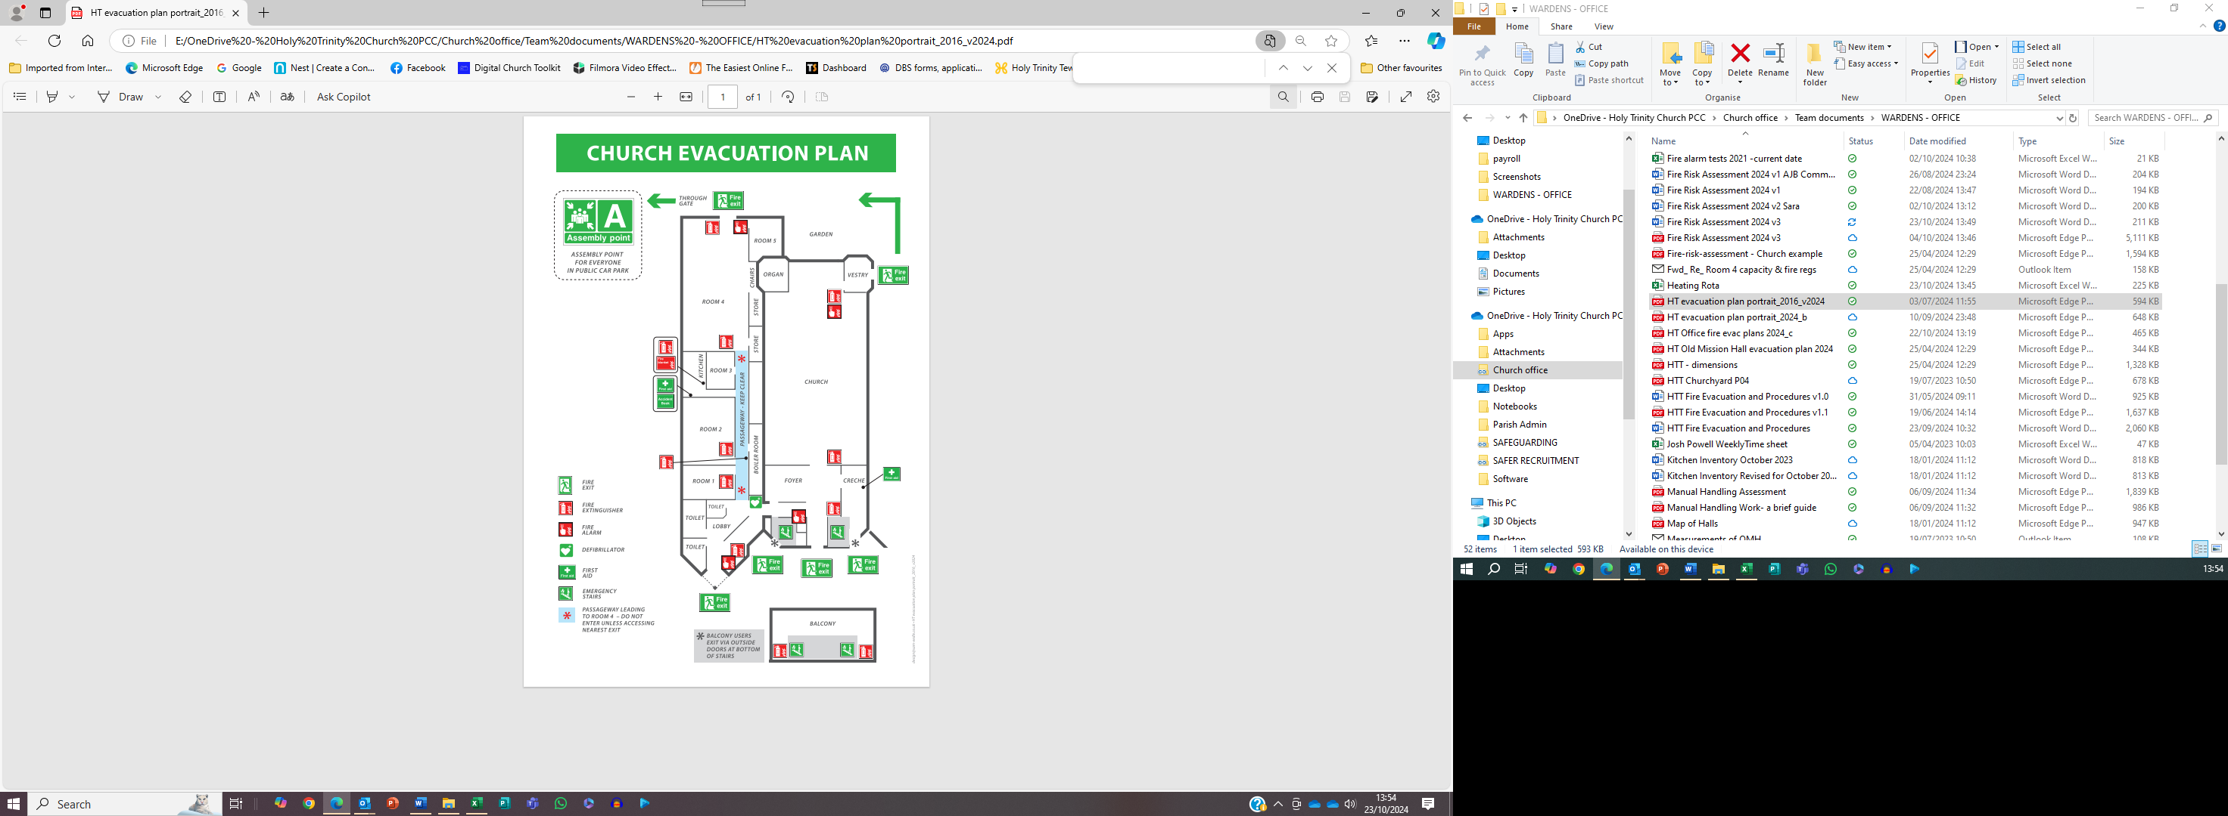

Plan of the OMH
- HT Old Mission Hall evacuation plan 2024.pdf
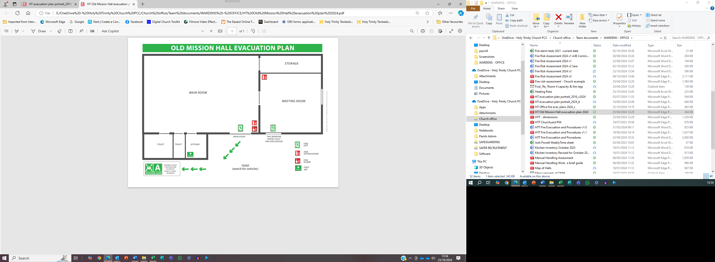

Plan of the office
- HT Office fire evac plans 2024_c.pdf

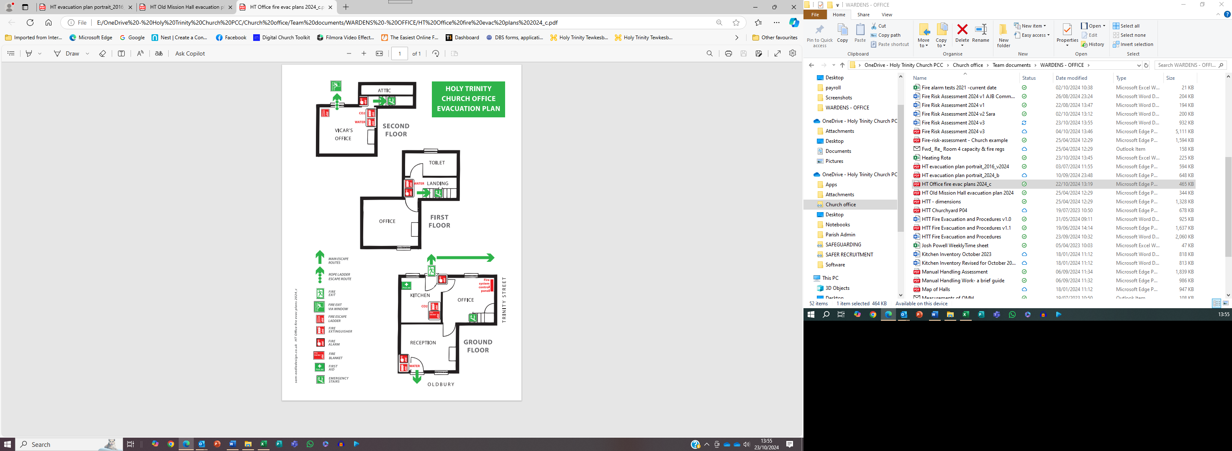

Part 4 – Our Action Plan To Reduce Fire Risk At Our Church

Current Mitigations
Hazard | Mitigation | Risk
Fire in vestry blocks east exit | West exit has higher capacity. Close door to vestry if possible. High ceiling to Nave allows smoke to disperse giving time for evacuation | Tolerable
Fire and smoke in Foyer, blocking west exit from Nave | Slower exit through Vestry. Mobility impaired users need to be assisted into vestry, which may be used as a place of safety if external stairs difficult. Keep Foyer doors closed. Balcony and creche have independent fire doors Close internal doors to balcony stairs to prevent smoke. High ceiling to nave will slow smoke buildup. | Tolerable
Fire alarms not linked between Church and Hall | Almost separate buildings with only one interconnecting door. Wardens deputed to raise alarm | Tolerable
Fire in hall corridor blocks exits from room 1 | Smoke alarms in corridor | Needs action
Fire in hall corridor blocks exits from kitchen and room 2 | Step stool provided in kitchen to access hatch to room 4. Chairs in room 2 provide access to hatch to kitchen and room 4 | Tolerable
Cooker fire in kitchen prevents access to kitchen door | Step stool provided in kitchen to access hatch to room 4. | Tolerable
Fire in Halls lobby blocks ramp exit from church | Temporary ramp provided in church porch for wheelchair users | Tolerable
Office: 1st and 2nd floors have single staircase with limited fire separation. 2nd floor office exceeds travel distance. | Provided additional chain ladder exits from windows to kitchen roof and yard. | Tolerable

Action Plan
Schedule of actions to be taken as a result of our fact-finding exercise in order to maintain our risk as low and to meet our Fire Safety Management Plan.

.
Hazard | Action /mitigation to be Taken | Target Completion | Person Responsible
Limited emergency light for balcony | Add new emergency lights
Office: 1st and 2nd floors have single staircase with limited fire separation. 2nd floor office exceeds travel distance. | Provide additional chain ladder exits from windows to kitchen roof and yard | 10/10/24 | AB
No Fire evacuation plan for office | Create plan | 20/10/24 | AB
Fire in hall corridor blocks exits from room 1,2 and kitchen | Consider linked smoke alarms to give early warning of fire
Room 4 – emergency lights on exits only | Replace some ceiling lights with emergency fitted lights | Following completion of heating works

Additional Notes

End of document

This number is only reached for the Christmas Christingle service. Additional stewarding and precautions are taken to mitigate the fire risk based on a specific risk assessment for the event
The window blinds are however fire retardant material.
1st and 2nd floor offices are not accessible to users with limited mobility, so exit via ladder

