Holy Trinity Tewkesbury

Fire Evacuation Policy

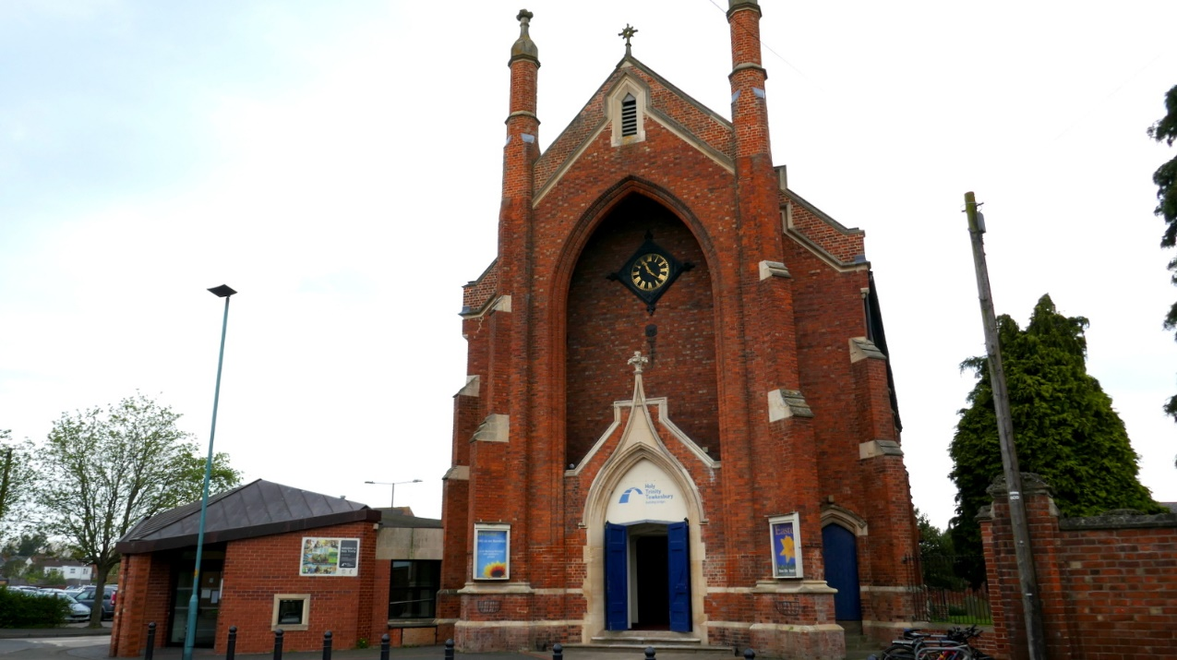

|  |  |
| --- | --- |
| Version Number | 2024-1 |
| Date Approved |  |
| Author | Alan Bedford – Church Warden |
| Review | Sara Simpkins |

Version History

|  |  |  |
| --- | --- | --- |
| Version | Comment | Date |
| 1.0 | For initial training session | 30/05/2024 |
| 1.1 | Incorporating feedback from training session | 19/06/24 |
| 1.2 | Change of Assembly point following fire drill | 10/09/24 |
| 1.3 | Addition of Church Office Procedures | 07/11/2024 |

A copy of this document to be kept in Church foyer for use in emergency.

# Contents

Contents

Contents 2

Introduction 3

Responsible Person 3

Procedure – on discovering a fire 4

Church Nave and Balcony 4

Church Halls 5

Old Mission Hall 6

Office 6

Procedure – Fire Evacuation Responsible Persons and Assistants 7

Sunday Morning Worship Service Procedures 7

Room Bookings Procedures 9

Large Events Procedures 10

Old Mission Hall Procedures 11

Church Office Procedures 12

Fire Safety Policies 13

Appendices 14

Evacuation Plan – Church 14

Evacuation Plan - Old Mission Hall 15

Evacuation Plan – Office 15

Assembly Point – Room List 16

Signage Examples 17

# Introduction

An outbreak of fire anywhere within the premises has the potential to cause significant risk to life and property. The emergency procedures provided within this document sets out the actions that occupants should take in the event of a fire emergency. The purpose of the procedures is to ensure that people in the premises know what key actions are required to be carried out in the event of fire and know what to do to safely evacuate the premises. All occupants using or having control of the building to any extent should follow this procedural document as a minimum.

Suitable arrangements, by way of nominating key persons to assist during emergencies, will be required to carry out all the key duties listed within this document. The number of persons nominated to assist should relate to the size of the event and the expected number of persons using the building.

## Responsible Person

A nominated responsible person is in charge of fire evacuation for an event.

Assistant responsible persons may be nominated for larger events to assist the responsible person

For a Sunday morning worship service, the responsible person will be the **duty church warden**. Assistant responsible persons will be the **Welcome Team** and **off duty church wardens (if present)**, **TJC Group Leaders**

The planning of other events or regular activities should identify the responsible person

## Procedure – on discovering a fire

These procedures apply to those discovering a fire and any person using the premises when an alert is raised. They should be displayed on fire safety notices

### Church Nave and Balcony

|  |
| --- |
| **On Discovering Fire – Nave** |
| * **Raise the alert** by immediately giving the shouted warning of fire and/or by pressing the nearest red fire call point. * **Inform the Fire Evacuation Responsible Person** (who will be the duty Church Warden (Sunday mornings) or event leader (other times)), if possible and safe to do so. * **Immediately** leave the building using the nearest and safest fire exit, following any instructions from the Fire Evacuation Responsible Person or Assistants. * Report to **Fire Assembly Point**: - Car Park access road past churchyard gates * Ensure the emergency services have been summoned by dialling 999.   + **Location of the church:** Oldbury Road, Tewkesbury, GL20 5NB. What3Words:///barrel.altitude.broth |

|  |
| --- |
| **On Hearing the Shouted Warning of Fire or Audible Alarm Signal - Nave** |
| * **Immediately leave** the building using the nearest and safest fire exit, following any instructions from the Fire Evacuation Responsible Person or Assistants. * **Do not collect children from the halls –** they will be evacuated by their group leaders * For users with mobility issues, if the ramp exit via foyer and lobby is not useable because of the fire seek assistance from the responsible person in the foyer. * An additional fire exit is available through the Vestry room at the east end * Report to **Fire Assembly Point**: _Car Park access road past churchyard gates |

### Church Halls

|  |
| --- |
| **On Discovering Fire - Halls** |
| * **Raise the alert** by immediately giving the shouted warning of fire and/or by pressing the nearest red fire call point. * **Inform the Fire Evacuation Responsible Person** (who will be the duty Church Warden (Sunday mornings) or event leader (other times)), if possible and safe to do so. * **Leave the building** using the nearest and safest fire exit, following any instructions from the Fire Evacuation Responsible Person or Assistants. * If main exit from Room 2 or Kitchen is blocked, exit through kitchen hatchways using a stool or chair to access if necessary * **Report to** **Fire Assembly Point**: _ Car Park access road past churchyard gates * Ensure the emergency services have been summoned by dialling 999.   + **Location of the church:** Oldbury Road, Tewkesbury, GL20 5NB. What3Words:///barrel.altitude.broth |

|  |
| --- |
| **On Hearing the Shouted Warning of Fire or Audible Alarm Signal - Halls** |
| * **Immediately leave** the building using the nearest and safest fire exit, following any instructions from the Fire Evacuation Responsible Person or Assistants.   + If main exit from Room 2 or Kitchen is blocked, you should exit through kitchen hatchways to Room 4 using a stool or chair to climb on the worktop if necessary * **Close the room door** if you are last to leave the room. * Report to **Fire Assembly Point**: - Car Park access road past churchyard gates |

### Old Mission Hall

|  |
| --- |
| **On Discovering Fire -Old Mission Hall** |
| * **Raise the alert** by immediately giving the shouted warning of fire and/or by pressing the nearest red fire call point. * **Immediately leave** the building using the nearest and safest fire exit, following any instructions from the Fire Evacuation Responsible Person or Assistants. * **Close the room door** if you are last to leave the room. * Report to **Fire Assembly Point**: _ Car Park access road past churchyard gates * Check the emergency services have been summoned by dialling 999.   + **Location of Old Mission Hall** The Old Mission Hall, Trinity Street, Tewkesbury, Gloucestershire, GL20 5LH What3Words: ///lazy.point.should |

|  |
| --- |
| **On Hearing the Shouted Warning of Fire or Audible Alarm Signal – Old Mission Hall** |
| * **Immediately leave** the building using the nearest and safest fire exit, following any instructions from the Event Leader / Fire Evacuation Responsible Person or Assistants. * If main exit from Meeting Room to Main Room is blocked, use the window to the Yard * **Close the room door** if you are last to leave the room. * Report to **Fire Assembly Point**: _ Car Park access road past churchyard gates |

### Office

|  |
| --- |
| **On Discovering Fire – Church Office** |
| * **Raise the alert** by immediately giving the shouted warning of fire and/or by pressing the nearest red fire call point. * **Immediately leave** the building using the nearest and safest fire exit, following any instructions from the Fire Evacuation Responsible Person . * **Close the room door** if you are last to leave the room. * Report to **Fire Assembly Point**: _ Church Forecourt * Check the emergency services have been summoned by dialling 999.   + **Location of Church Office** 10 Oldbury Road, Tewkesbury, GL20 5NB   + What3Words: synthetic.stalemate.worked |

|  |
| --- |
| **On Hearing the Shouted Warning of Fire or Audible Alarm Signal – Church Office** |
| * **Immediately leave** the building using the nearest and safest fire exit, following any instructions from the Fire Evacuation Responsible Person. * If staircase from upper floors is blocked, use the evacuation ladder though the 2nd floor window to the kitchen roof. * **Close the room door** if you are last to leave the room. * Report to **Fire Assembly Point**: _ Church Forecourt |

## Procedure – Fire Evacuation Responsible Persons and Assistants

### Sunday Morning Worship Service Procedures

#### Prior to Service

The **Fire Evacuation Responsible Person** (Church Warden) shall

* Check Fire exits operate and are clear of obstruction
* Both double doors on exit routes without panic bars to be unbolted during building occupation (final door from Lobby remains on single bolts to control access to building)
* Check emergency wheelchair ramp is in cupboard by West door
* Visual inspection of fire extinguishers

**Assistant Responsible Persons** (Welcome Team, TJC Leaders, off-duty Wardens) shall:

* Encourage wheelchair users to sit near the West End of the nave closer to the ramp access.

#### **If alarm is sounded**

The **Fire Evacuation Responsible Person** (Church Warden) shall:

* Direct the assistant responsible persons to ensure occupants are aware of the alarm and are evacuating the building, directing persons to the assembly point
* Ensure all other fire alarm points are activated if safe to do so, directing assistants where possible
* Initiate the 999 call
* Take position in the Foyer to supervise evacuation
* Confirm the approximate location of the fire
* Ensure the balcony is clear (if necessary, by directing an assistant to check)
* Confirm the building is clear of all occupants as far as possible
* Stop parents from collecting children from the halls – advise that TJC leaders will evacuate
* Wear a HiVis vest to identify yourself (in cupboard by West door)
* Advise any groups in the Old Mission Hall that the church has been evacuated and not to be re-entered
* Go to **Fire Assembly Point once the building appears to be clear**: _ Car Park access road past churchyard gates
* Ensure the emergency services have been summoned by dialling 999.
  + **Location of the church:** Oldbury Road, Tewkesbury, GL20 5NB. What3Words:///barrel.altitude.broth
* Confirm with Assistants all areas are clear – use the checklist at the end of the document
* Return to area in front of West Entrance to meet Fire Service
* Meeting the Fire and Rescue Services on arrival
* Giving the signal to re-enter the building

**Assistant Responsible Persons** (Welcome Team, TJC Leaders, off-duty Wardens) shall:

* Ensure occupants are aware of the alarm and are evacuating the building, directing persons to the assembly point
* Assist occupants with mobility issues if necessary.
* Advise parents that staff will evacuate TJC children to assembly point
* No one should enter the hall corridor other than to proceed to the nearest exit
* Ensure all other fire alarm points are activated
* Sweep/search of areas of the building on way to exit
* TJC leaders should clear their rooms.
  + TJC to bring class register to assembly point
  + TJC leaders to check children against register before leaving and at assembly point
* If safe to do so, one member of Welcome Team to exit via Vestry and ensure free flow of evacuees and that Vestry is clear. A hi viz vest is available in the vestry to highlight role to evacuees
* If safe to do so, one member of the welcome team to check rooms 1 - 5 and kitchen are clear and toilets are clear
* Person responsible for Room 4 should check Kitchen is clear through hatch[1]. If necessary, assist persons through the hatch if other routes are blocked. A step stool is provided by the water boiler to ease access to the hatch. When clear close the hatch
* Person responsible for Room 4 should check Room 5 is clear. Close doors where safe to do so
* TJC Leader should assemble children in churchyard unless fire risk exceeds risk from traffic
* At the assembly point TJC leaders should check children against the register
* Check emergency services have been notified
* Report to the Responsible Person to confirm your area is clear

If a fire in the foyer blocks exit from the Nave, ensure doors to Nave and balcony are closed to contain smoke and thus allow additional time for evacuation through vestry. Persons with mobility issues who cannot descend the vestry external stairs, should then use the vestry as a place of safety with the door to the church closed.

### Room Bookings Procedures

These instructions to be provided to the booking contact

#### Prior to Event

The Fire Evacuation Responsible Person (Event Leader or another designated person) shall

* Identify Fire Exits
* Identify fire extinguishers
* Be aware of other users of the halls

#### If alarm is sounded

The Fire Evacuation Responsible Person shall:

* Ensure the emergency services have been summoned by dialling 999.
  + **Location of the church:** Oldbury Road, Tewkesbury, GL20 5NB. What3Words:///barrel.altitude.broth
* Confirm the approximate location of the fire
* Sweep/search of areas of the building on way to exit including Toilets
* Confirm the building is clear of all occupants as far as possible
* Advise any groups in the Old Mission Hall (Trinity Street) that the church has been evacuated and not to be re-entered
* Meet the Fire and Rescue Services on arrival
* Giving the signal to re-enter the building
* Person responsible for Room 4 should check Kitchen is clear through hatch[2]. If necessary, assist persons through the hatch if other routes are blocked. A step stool is provided by the water boiler to ease access to the hatch. When clear close the hatch

### Large Events Procedures

For special events using both the church and halls and involving larger numbers of people, document appropriate procedures based on the Sunday Morning Worship as part of the event risk assessment

### Old Mission Hall Procedures

This facility comprises two meeting rooms for a single event.

#### Prior to Event

The Fire Evacuation Responsible Person (Event Leader) shall

* Identify Fire Exits (2)
* Identify fire extinguishers

#### If alarm is sounded

The Fire Evacuation Responsible Person shall:

* Check the emergency services have been summoned by dialling 999.
  + **Location of Old Mission Hall** The Old Mission Hall, Trinity Street, Tewkesbury, Gloucestershire, GL20 5LH What3Words: ///lazy.point.should
* Confirm the approximate location of the fire
* Sweep/search both areas of the building on way to exit including Toilets
* Confirm the building is clear of all occupants.
* For a related event, inform the main church of the evacuation
* Meet the Fire and Rescue Services on arrival
* Give the signal to re-enter the building

### Church Office Procedures

The church office is a converted house over three floors.

#### Background Responsibilities

The Fire Evacuation Responsible Person (Church Administrator) shall

* Ensure routes to front and rear fire exits on ground floor are kept clear
* When empty, close office / kitchen internal doors to contain any fire
* Test fire alarm system monthly / check upstairs windows not locked / Escape ladder present on 2nd floor
* Test emergency lights (Church warden task)

#### If alarm is sounded

The Fire Evacuation Responsible Person (Church Administrator) shall:

* Check the emergency services have been summoned by dialling 999.
  + **Location of Church Office** 10 Oldbury Road, Tewkesbury, GL20 5NA What3Words: ///parked.reporters.tadpoles
* Confirm the approximate location of the fire
* Confirm the building is clear of all occupants.
  + Check on regular users by mobile phone if unsure
* Meet the Fire and Rescue Services on arrival
* Give the signal to re-enter the building

## Fire Safety Policies

#### Contractors

Will be briefed on the key fire action procedures and specific fire safety information for the building on arrival.

Contractors will be responsible for their own evacuation

A risk assessment and procedures should be defined for items of work, appropriate to the size and complexity of the task.

Care should be taken to avoid lone working in the attic space

Any hot work (Soldering, welding, blowtorch etc) must have a statement of risk and precautions needed, and these should be followed.

Contractors will be responsible for all persons in their care during an emergency, and for summoning and meeting the Fire and Rescue Services, where they have full control of the building outwith normal opening hours. They should be aware of other users in the building.

#### Lettings

Organiser will be provided with a copy of the procedures.

Organiser must identify the Responsible Person for the booking.

The event leader must advise attendees of location of fire exits and assembly point.

Smoking is not permitted.

No naked flames (other than agreed use of cooker) or smoke machines are allowed.

#### All Users

Ensure fire exits are kept clear.

Any small electrical item brought onto the premises must be PAT tested.

Only fixed electrical heaters should be used. Damaged electrical equipment should be reported to office / church wardens and removed from use.

No smoking within the building.

Only authorised use of cooking facilities.

No deep fat frying

Flammable chemicals should be stored in the shed.

## Appendices

### Evacuation Plan – Church

### Evacuation Plan - Old Mission Hall

### Evacuation Plan – Office

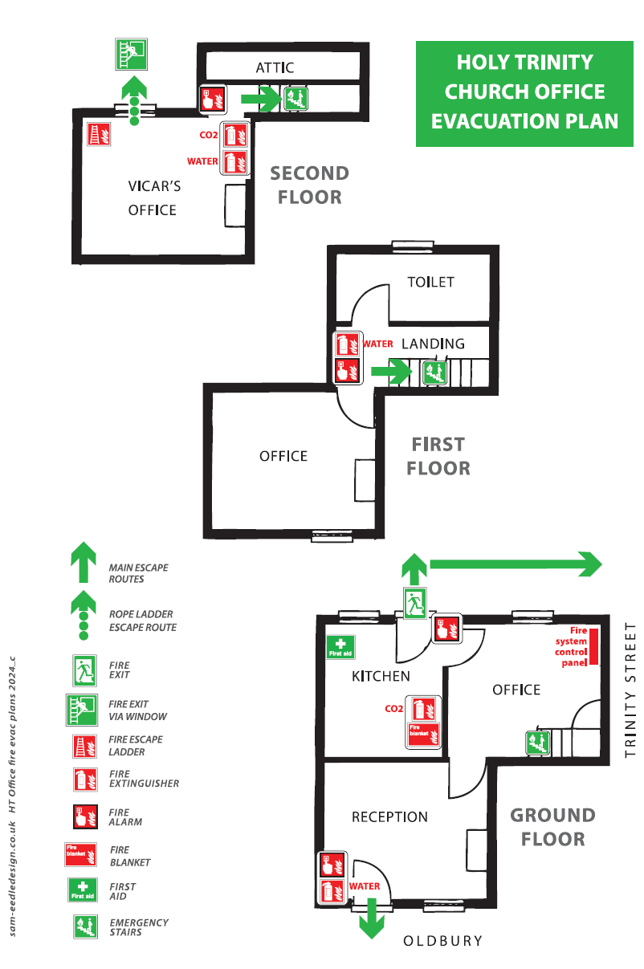

### Assembly Point – Room List

This sheet to be taken to assembly point

**Evacuation Checklist**

|  |  |  |
| --- | --- | --- |
| Room | Group | Checked / Initials |
| 1 |  |  |
| 2 |  |  |
| 3 (storeroom) |  |  |
| 4 |  |  |
| 5 |  |  |
| Creche |  |  |
| Kitchen |  |  |
| Balcony |  |  |
| Nave |  |  |
| Toilets (M, F, Disabled) |  |  |
| OMH – Group advised |  |  |

### Notes:

### Signage Examples

Church Nave

Church Halls

1. If hatch is already closed, check there is not fire behind it before opening
2. If hatch is already closed, check there is not fire behind it before opening