Sunday 13th June – Portraits of Prayer
The Confession of David
- How would you define sin?
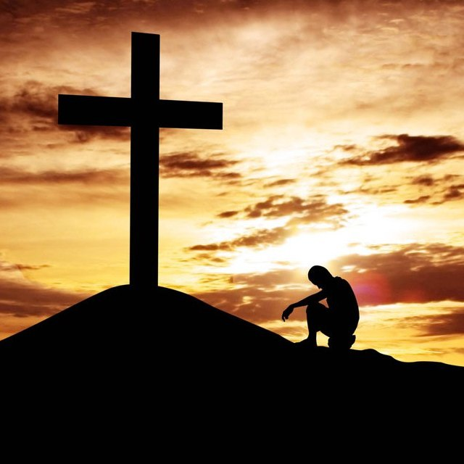
- How do you know when you have sinned?
- What makes you hide your sin from others?
Read Psalm 32:1-5
- What does this tell us about the importance of confession?
- Have you ever experienced illness or discomfort due to unconfessed sin?
- What might stop us from confessing our sins to God?
Read Psalm 51:1-12
- Why do you think David said that he had only sinned against God? (v4) What about Bathsheba?
- When you have wronged someone, how important is it that you make amends? (See Leviticus 6:2-5)
- If someone we have wronged does not forgive us when we have tried to make amends; does that affect our relationship with God?
- What could God do for David that Bathsheba could not?
Pray
- Read 1 John 1:5-10
- Take some time in silence or with music playing to think about the things that you need to put right with God.
- Confess your sins either quietly in your hearts or join together in a standard form of confession

